Health and Safety Policy Statement

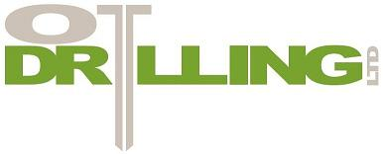

Statement of Intent

It is the policy of OT Drilling Ltd to comply with the terms of the Health and Safety at Work Act and any subsequent legislation and to provide and maintain a healthy and safe working environment.
OT Drilling Ltd will strive to reduce the number of work related injuries and illnesses to as close to zero as possible.

All employees will be provided with such equipment, information, training and supervision as is necessary to implement the policy.

OT Drilling Ltd recognise and accept their duty of care towards their employees, as well as any visitors that may come to site.

While the management of OT Drilling Ltd will do all that is within their power to ensure the health and safety of employees, it is recognised that health and safety at work is the responsibility of each and every individual associated with the company. It is the duty of each employee to take reasonable steps to ensure his own and other peoples health, safety and welfare, and report any situation that is unsafe to management.

The health and safety policy will be continually monitored and reviewed at least annually.

Signed:

Date:

Owen Thomas
Director of Health and Safety Review Date:

